Sender Address Verification

# Sender Address Verification (SAV) helps keep unwanted bulk email out of your inbox. Here’s how it works.

## If you have Sendio, here’s what happens when someone outside of your email community sends you an email…

# The SAV Email

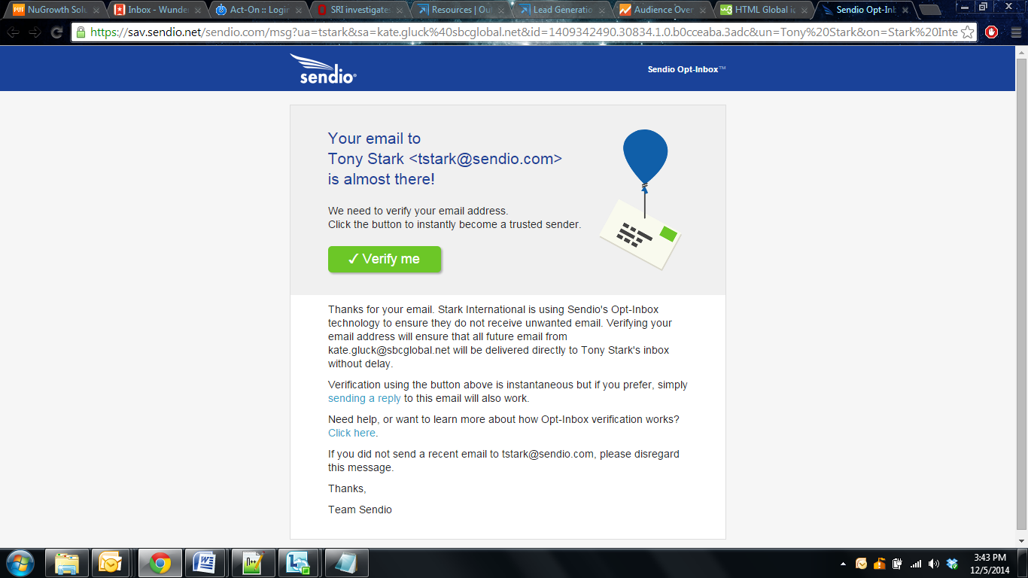

|  |  |  |  |
| --- | --- | --- | --- |
| 1. The email is sent to you. | 2. The sender instantly receives the SAV email. | 3. The sender clicks “Verify Me” and the email – and all future emails from this sender – is delivered to your inbox. | 4. If the email sender never clicked “Verify Me,” you can manually release the email from the Email Queue into your inbox. |

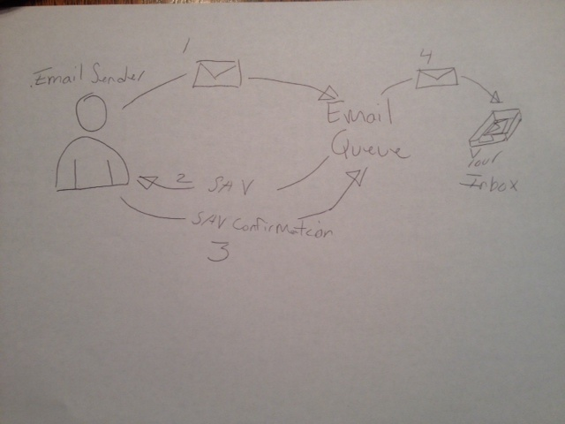

## Until the sender clicks “Verify me,” the email will be in your Email Queue – a virtual holding pen for your pending emails – waiting for your approval to enter your inbox.